Migrating A Web(Java) Application To
AWS Cloud
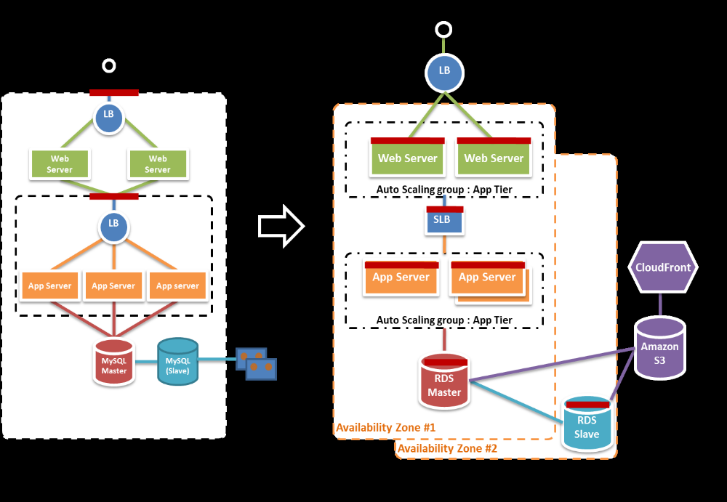

Services Required

EC2, S3, EBS, SimpleDB, AS,ELB(Elastic Load Balancing),AS(AutoScaling),CW(CloudWatch),RDS(Relational Database System)

Data Migration

Move all of the application’s static files (Images, JS, CSS, video, audio, and static HTML content) into an Amazon S3 bucket, create a CloudFront distribution of that Amazon S3 bucket, and modify the references in web pages so that end-users get the content directly from Amazon S3 and Amazon CloudFront. With a few scripts and the AWS SDK for Java library, we can transfer all data from tape drives and upload it to Amazon S3.

Application Migration

During the application migration phase, the development team can launch both small and large instances3 for their web and tomcat servers. They can create AMIs (Amazon Machine Images, basically “golden” system images) for each server type. AMIs can be designed to boot directly from an EBS volume and fetch the latest WAR file binaries during launch from the source code repository. They can modify their build and deployment scripts to use the cloud as an endpoint. Security Groups have to be defined to isolate web servers from the applications and database servers. Testing (functional, load, performance etc.) can be performed to ensure that the systems are performing at expected levels, and that exit criteria for each component are met.

Co-existence Phase

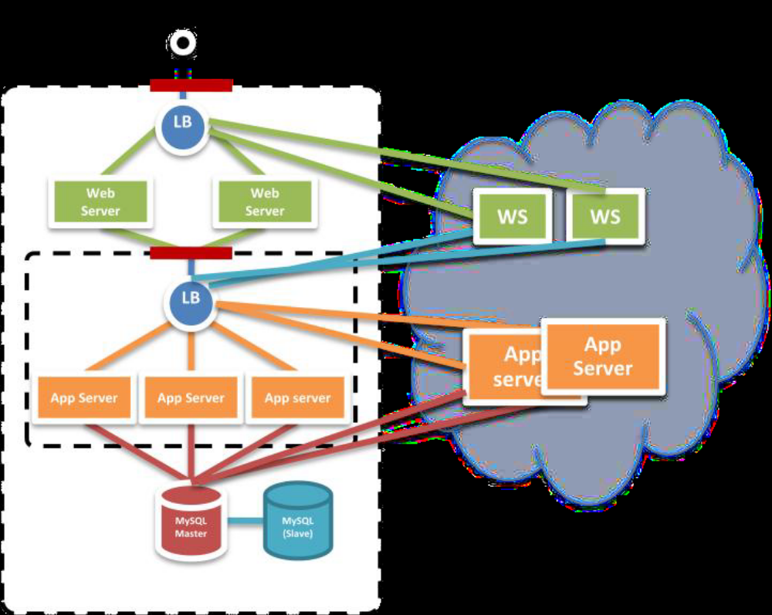

During the migration phase, the Company can deploy a hybrid migration strategy during the migration of all web and application servers. The configuration of the on-premise hardware load balancer needs to be modified to send requests to the new instances in the cloud. For a short duration, the load balancer will start routing traffic to the servers in the cloud in as well as to the physical servers. After verifying that the servers in the cloud are performing at required levels, the physical servers can be dismissed one by one, the load balancers then can be updated, and all of the web traffic will then be served up by the EC2 instances running in the cloud.
After testing is over, the DNS has to be switched to point to the cloud-based web servers and the application in this way gets fully migrated to the AWS cloud.

